Learner’s Word of the Day

June 28, 2021

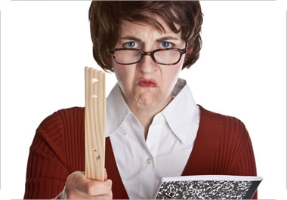

The teacher is known for cracking down on her students.

crack down /ˈkræk ˈdaʊn/ phrasal verb

: to start to be strict about punishing people for doing something that is illegal or not allowed : to enforce a law or rule more strictly
People have been violating this law for years, and now the government is finally starting to crack down.
— often + on
Authorities are cracking down on companies that pollute.

