Learner’s Word of the Day

June 14, 2021

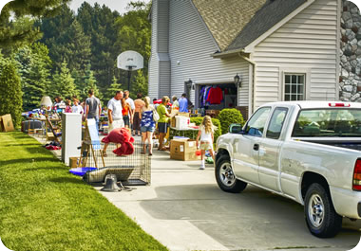

The family is having a garage sale.

garage sale /gəˈrɑːʒ ˈseɪl / noun

[count] chiefly US
: a sale of used furniture, clothing, etc., held at the seller's home

