Learner’s Word of the Day

June 22, 2021

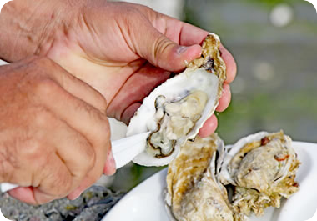

Some people consider oysters to be a delicacy; other people think theyâ€™re yucky.

yucky /ˈjʌki/ adjective

informal
1 : causing discomfort, disgust, or a strong feeling of dislike : unpleasant and disgusting
The water was dirty and smelled yucky.
yucky food
2 : having an unpleasant feeling in your stomach : somewhat sick
I felt yucky after eating all that cake.

